SOCIAL STUDIES
GRADE: V DATE: 6 .11.20
WORKSHEET - 14
14. The world from 1914 to 1945
I.Choose the correct Answer
1. The First world war was also called ______________ .
a. Civil war b. Great war c. Sepoy Mutiny
2.The League of nations was formed after the ___________ .
a. Second world war b. First world war c. Gulf war
3. When did the first world war start?
a. July 1914 b. November 1918 c. May 1945
4. The leader of Germany during the second world war was __________ .
a. Benito Mussolini b. Adolf Hitler c. Winston Churchill
5.The Second world war ended in the year __________.
a. 1947 b. 1918 c.1945
II. Name the following
1. The place where the Germans kept Jews as prisoners. _________________.
2. The treaty that ended the First World War. _________________ .
3. Leader of the Nazi party. _______________.
4. The peace organisation formed after the Second World War.____________ .
5.An organization formed after the First World War to maintain peace in the world war.____________

III. Answer the following?
1. What is Holocaust?

2 .Name the weapons used in First World War and Second World War.

3 .How was Germany punished after the First World War?

IV. Look at the picture of U- boat. Answer the following

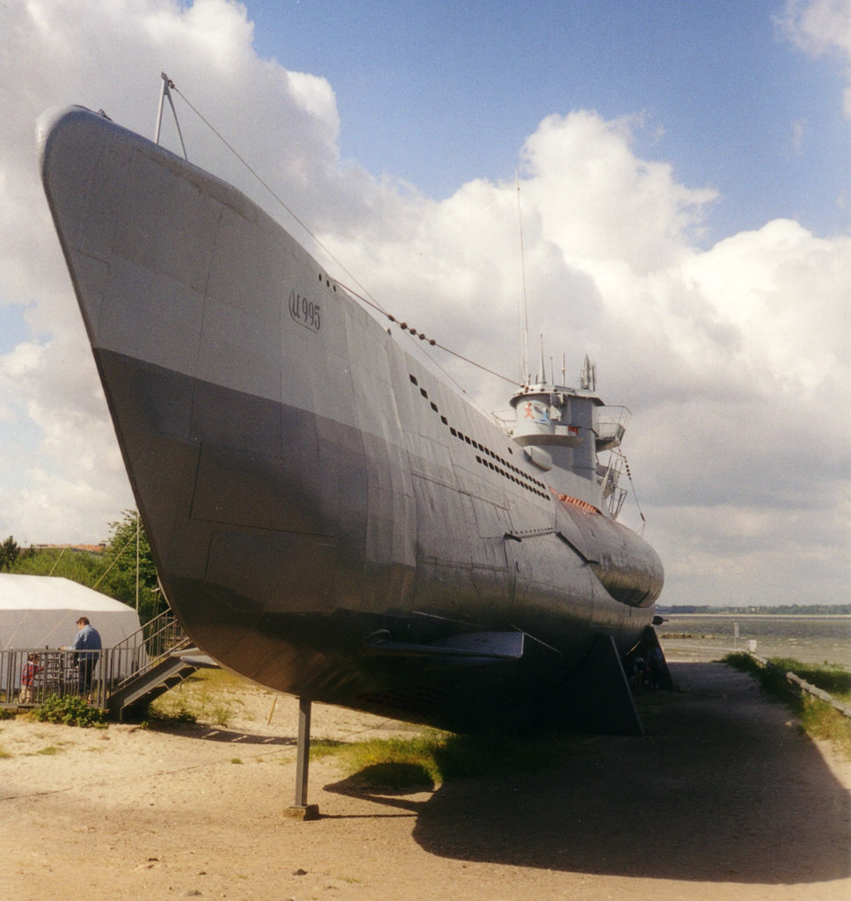
1. What were U-boat?

2. In which war were the u-boats first used?

3. Which Power used U-Boats in the war-Allied powers or the Central powers?

1

